**Implement an image moderation solution with Azure AI Content Safety**

The moderate image content tool considers several factors such as the type of content, the platform's policies, and the potential effect on users. You can run moderation tests on sample content and configure filters to rerun and further refine the test results.

You can run tests on images to ensure that they meet your content standards.

1. Violence
2. Self-harm
3. Sexual
4. Hate

Maximum size for image: 4MB

Size between 50px x 50px & 2048px x 2048px.

Type: JPEG, PNG, GIF, BMP, TIFF, or WEBP formats

MS Learning : <https://learn.microsoft.com/en-us/shows/azure-ai-content-safety/azure-ai-content-safety-image-moderation>

**Steps for Creating Content Safety Resource**

**Step 1.**Go to the [Azure](http://portal.azure.com/) portal and sign in with your Azure account.

**Step 2**. Search**"Content Safety"**in the search bar and select **"Content Safety"** from the search results.

**Step 3.** Click on the Create button for Content Safety.

**Step 4.** First, choose a subscription and then create a Resource Group named testRG, and type the resource name as retailcontentsafe.

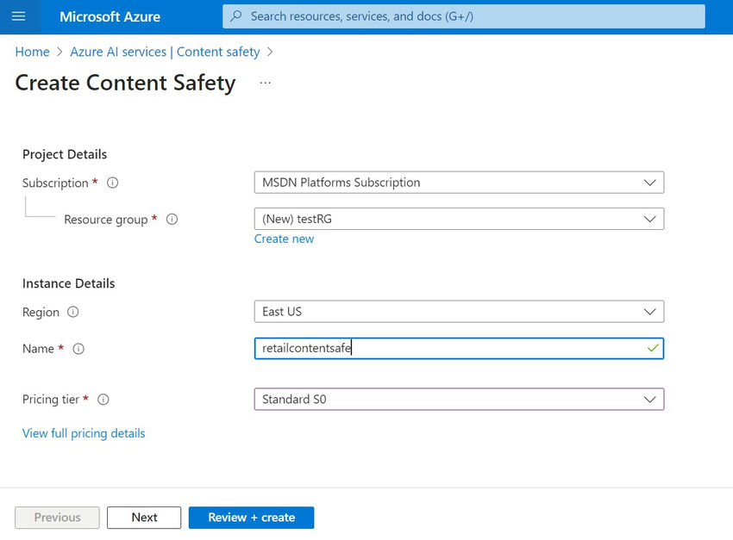

**Step 5.** Click the Review+Create button.

**Step 6.**Finally, Click the Create button.

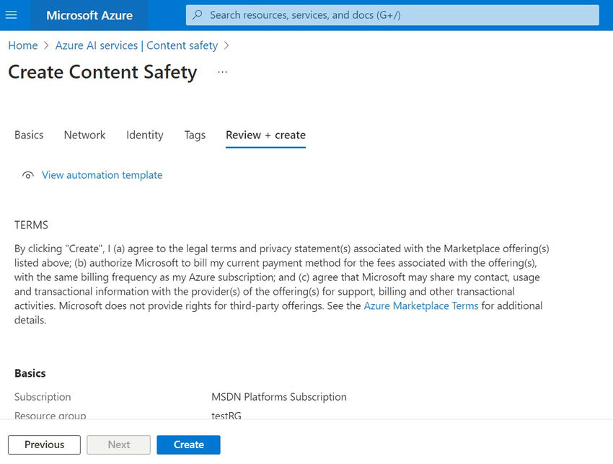

**Step 7**. Deployment started in progress in a minute or two deployment will become successful.

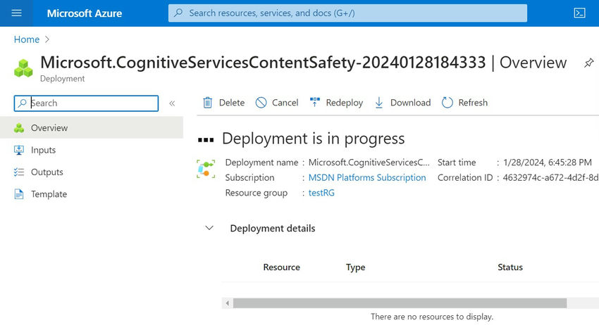

**Step 8**. You can see deployment is completed successfully.

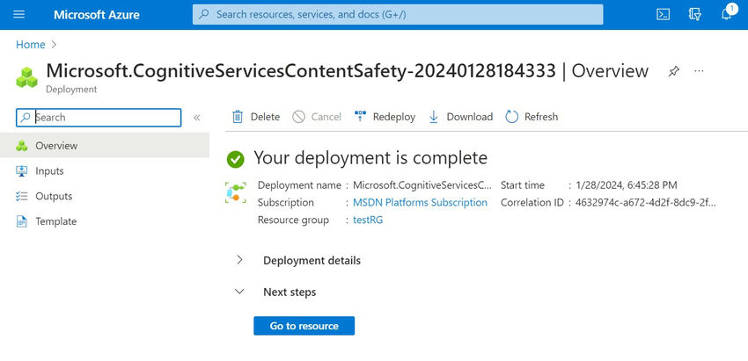

**Get Started with Content Safety Studio**

**Step 1.** Click Content Safety Studio from the Azure Portal.

**Step 2.**Now you are going to run a moderation test related to the Images.

**Step 3.** Click Try it out for Moderate Images Content.

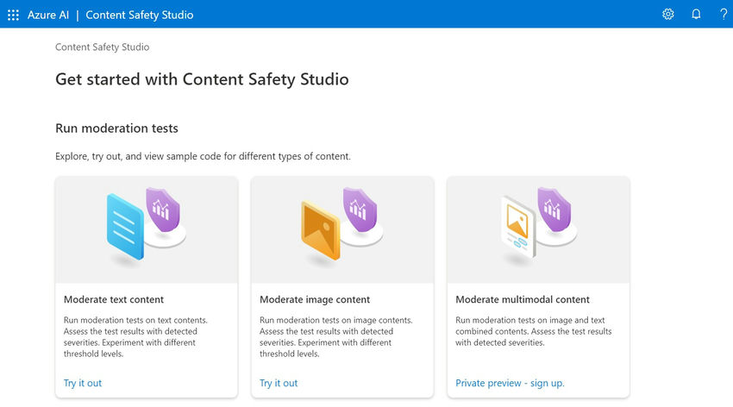

Safe Content Scenario

**Step 4.** Click Run a Simple Test and choose the Safe Content option from the moderate image content.

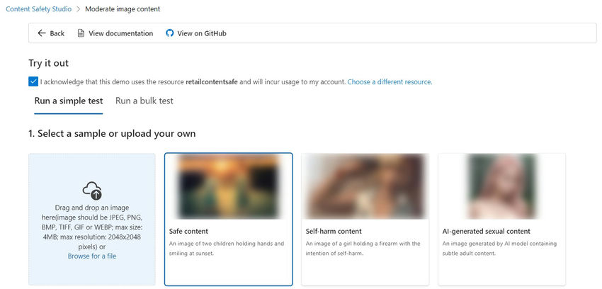

**Step 5.** Prompt - An image of two children holding hands and smiling at sunset.

**Step 6.**Click the run test button and it's going to be determined whether the status of the prompt is allowed or blocked in the Judgement option.

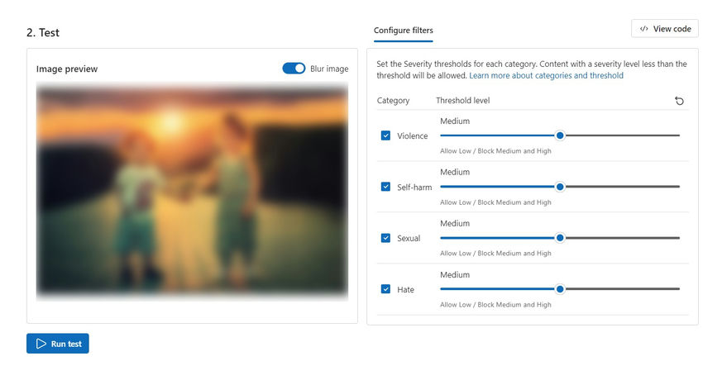

**Step 7.** In the View results section, Prompt content has been allowed and you can also see the category and risk level detection results below.

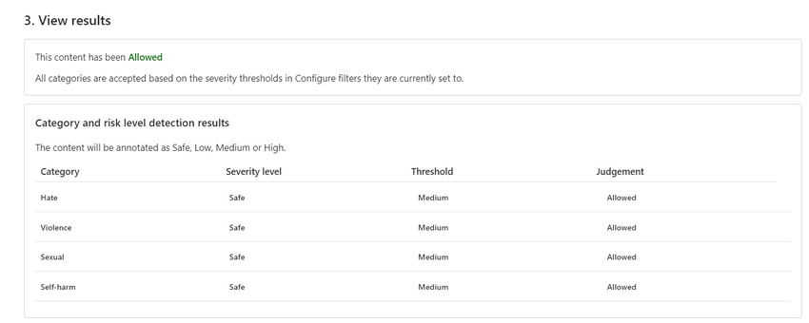

**Self-harm Content Scenario**

**Step 1.** Click Run a Simple Test and choose the Self-harm content option from the moderate image content.

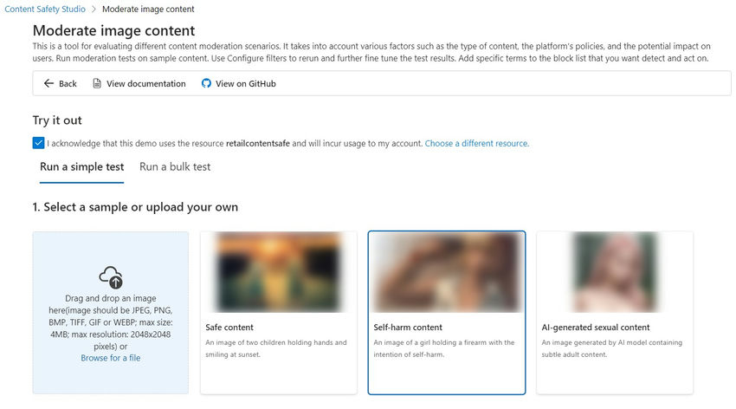

**Step 2.**Prompt - An image of a girl holding a firearm with the intention of self-harm.

**Step 3.** Click the run test button and it's going to be determined whether the status of the prompt is allowed or blocked in the Judgement option.

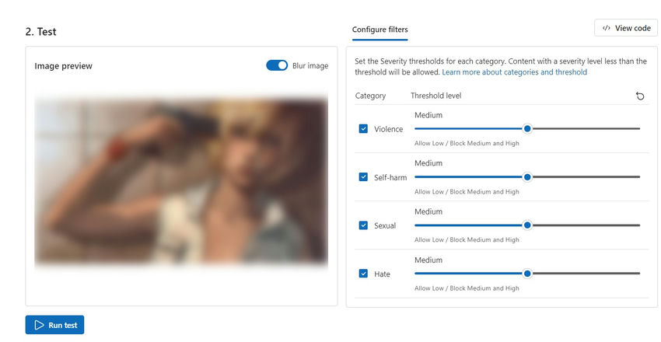

**Step 4**. In the View results section, Prompt content has been blocked and you can also see the category and risk level detection results below.

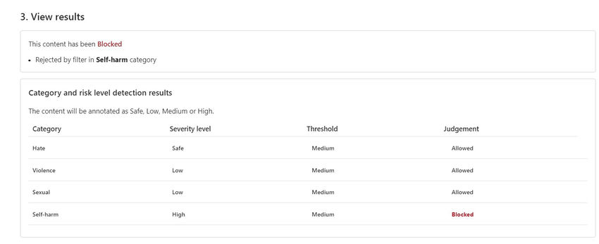

**Run a bulk test Scenario**

**Step 1.**Click Run a Bulk Test and choose the dataset with a safe content option from the moderate image content.

**Step 2.**In this context I have taken a dataset with 15 records and with corresponding label 0 indicates its safe content.

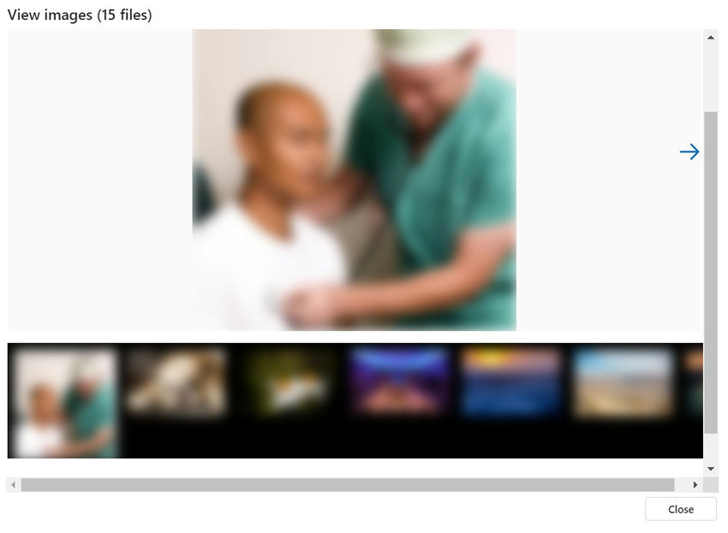

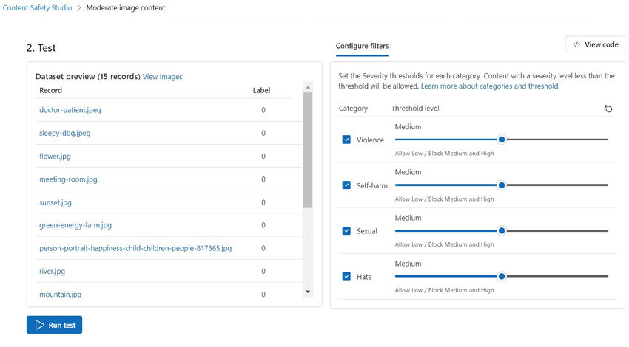

**Step 3.** Click the run test button and it's going to be determined whether the status of the prompt is allowed or blocked in the Judgement option.

**Step 4.**In the View results section, Prompt content has been allowed and you can also see the category and risk level detection results below.

